6) Maxwell Tedder
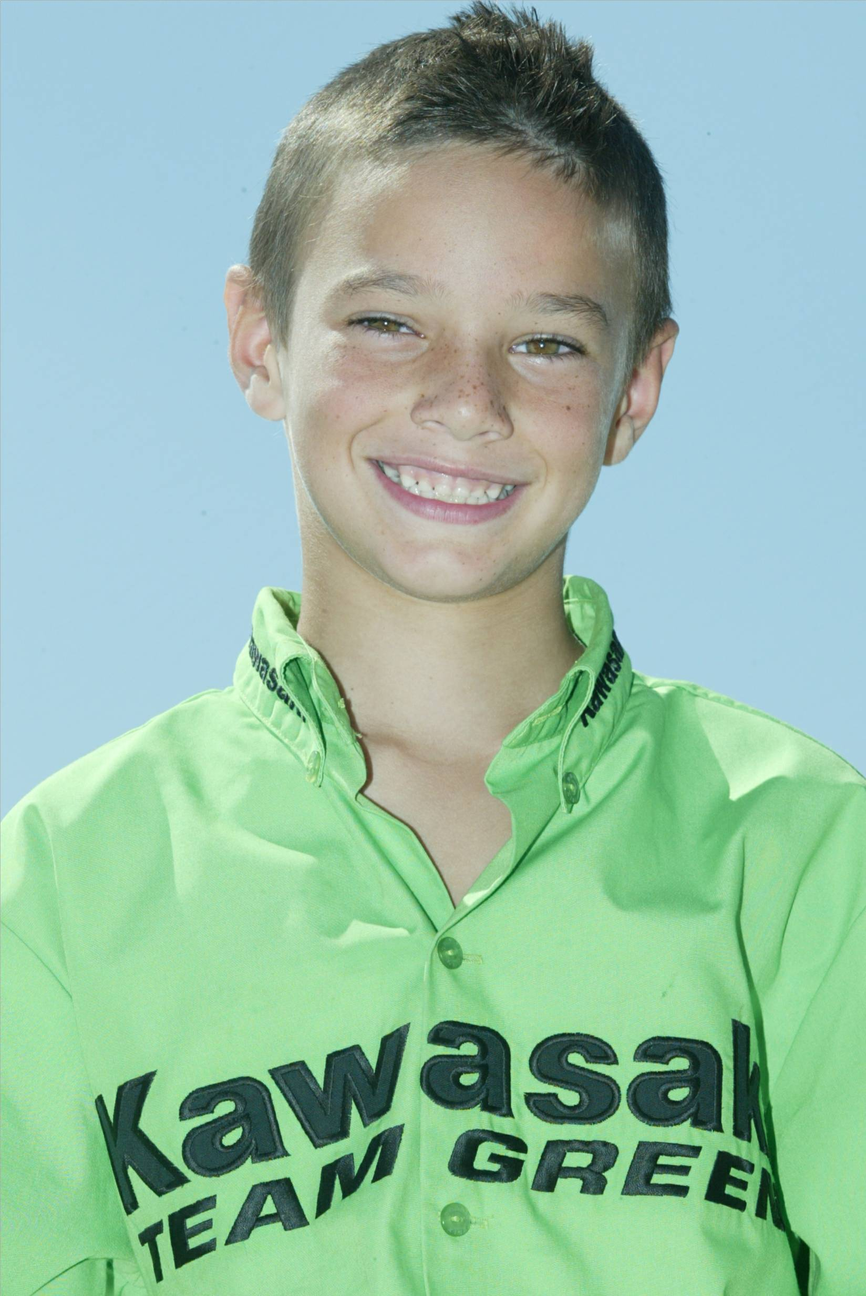

Racing Classes: 65cc 8-11 Yr and 50cc Pee Wee 6-8 yr Expert

Occupation: Fulltime Student St. Hedwig Catholic School

Hobbies: Moto-X, Snow Boarding, Boogie Boarding

Motorcycle: Kawasaki 65, Cobra 50

Age: 8

Racing Accomplishments:

- 2nd Overall CMC Golden State Series 6-8 50cc Class
- 4th Overall CMC Golden State Series 65cc 8-11
- 32nd Overall 2004 Loretta Lynn’s 4-6 Stock 50cc Class

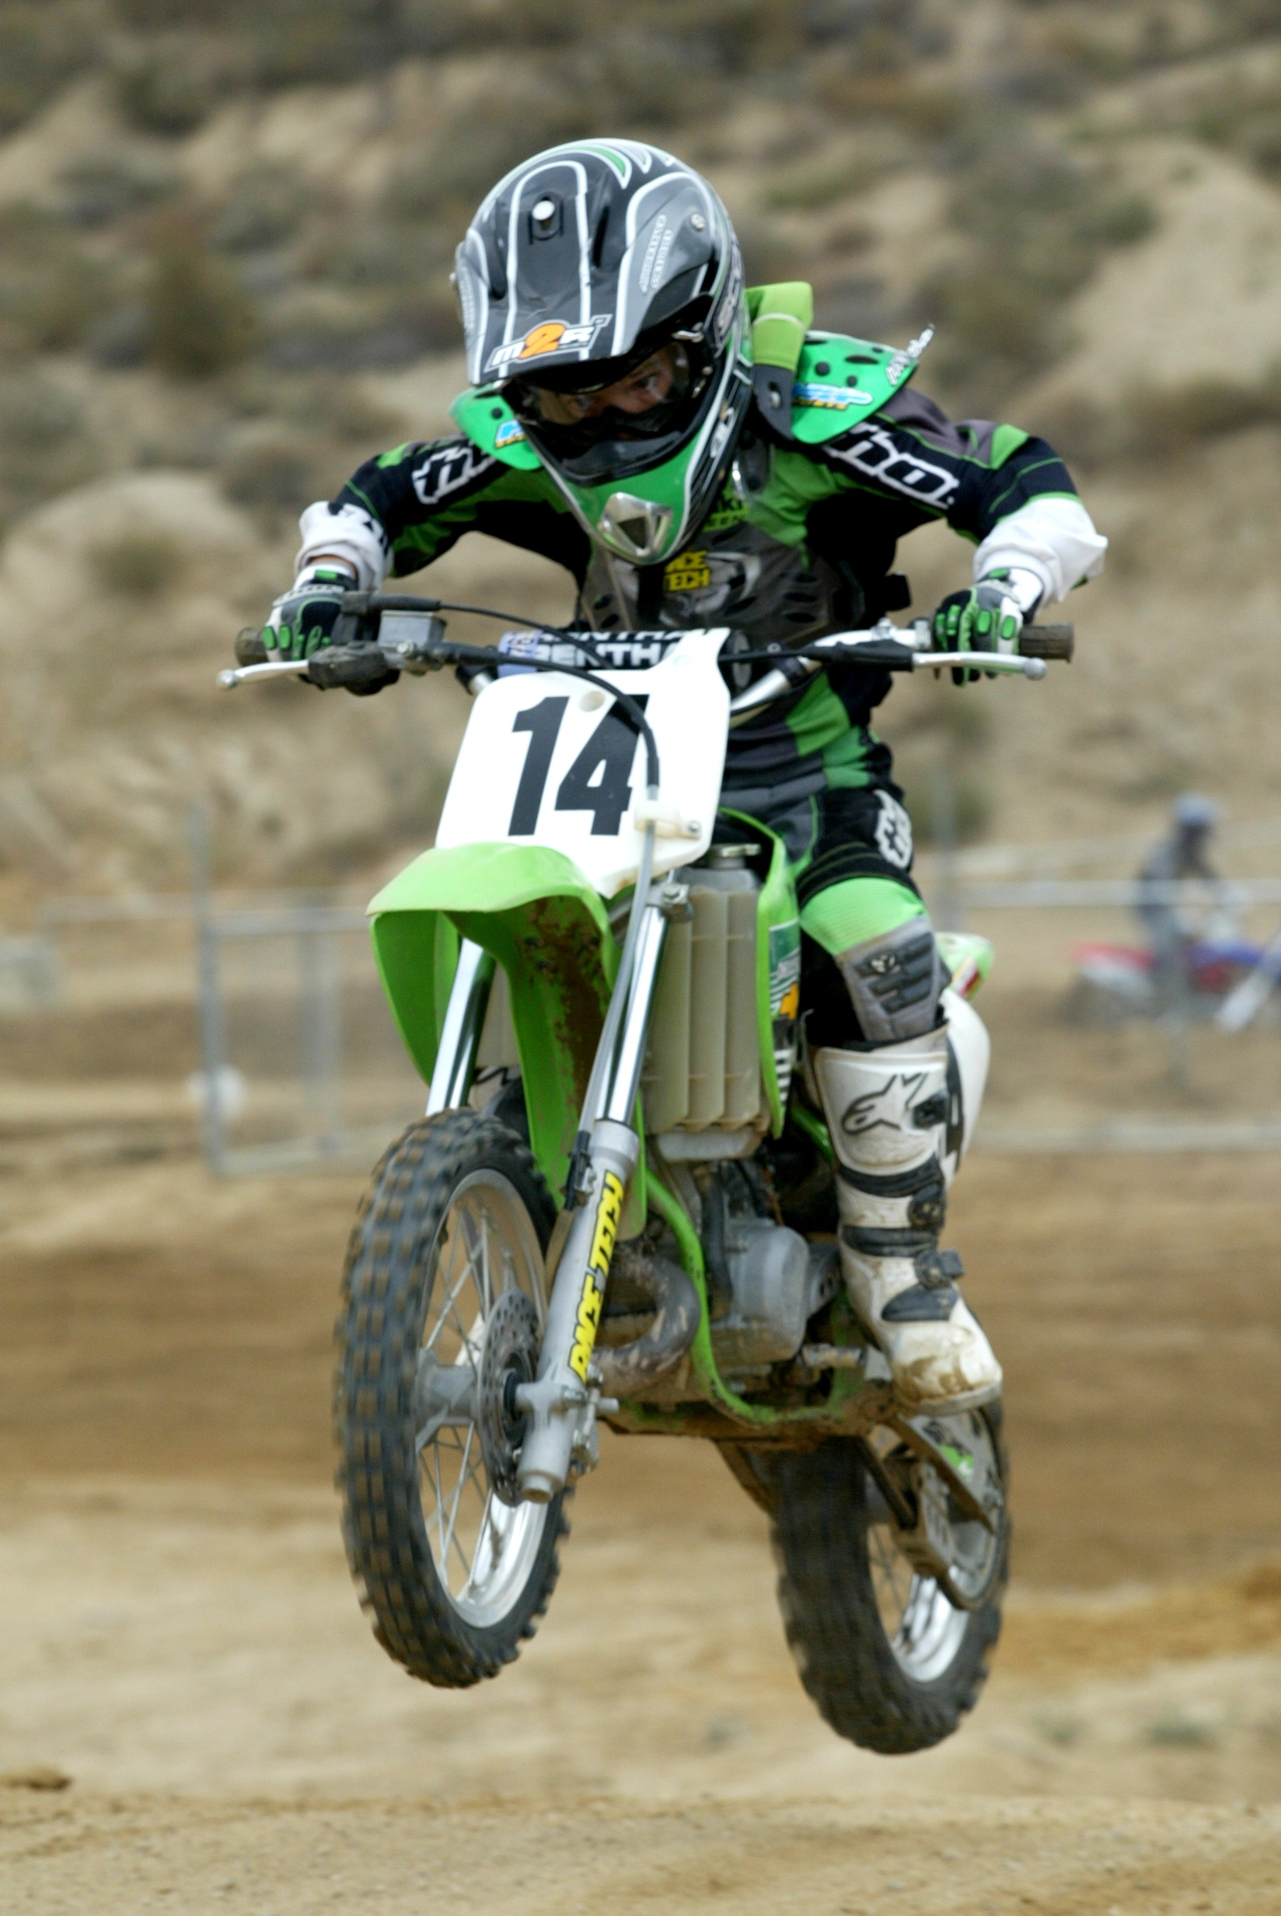
2005 Racing Results:

Maxwell has been racing since 4 years old. He just recently turned 8 and wins Local events. However, he is a newcomer to the 65cc and 85cc class and is quickly maturing. Maxwell is big for his age and will be competing more in the 85cc class.

2005 2nd Overall:

- 2005 CMC Golden State Series
2nd: Overall 50cc 7-8

2006 Goals:

- Finish Top 10 at National events.
- Win local events.

